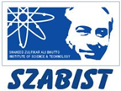 **Introduction to DevOps**

**BCS/BS 6A**

Lab: 05

# GROUP MEMBERS:

MUHAMMAD SHAYAN SHAHID (2212325)

MUHAMMAD ASHAD BAIG (2212115)

Task 1: Create an Azure Key Vault

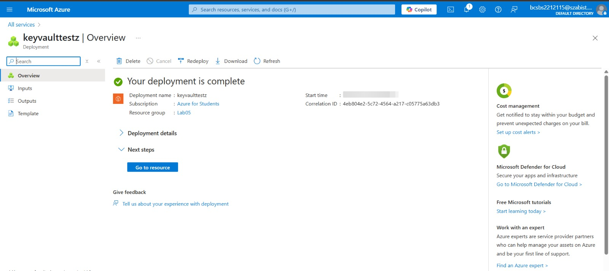

Task 2: Add a secret to the Key Vault

